#5 – J.K. Rowling
PHOTO CREDIT: TELEGRAPH.CO.UK
Rowling is one of the most inspirational success stories of our time. Many people simply know her as the woman who created Harry Potter. But, what most people don’t know is what she went through prior to reaching stardom. Rowling’s life was not peaches and cream. She struggled tremendously.
In 1990, Rowling first had the idea for Harry Potter. She stated that the idea came “fully formed” into her mind one day while she was on a train from Manchester to London. She began writing furiously. However, later that year, her mother died after 10 years of complications from Multiple Sclerosis.
In 1992 she moved to Portugal to teach English where she met a man, married, and had a daughter. In 1993, her marriage ended in divorce and she moved to Edinburgh, Scotland to be closer to her sister. At that time, she had three chapters of Harry Potter in her suitcase.
Rowling saw herself as a failure at this time. She was jobless, divorced, penniless, and with a dependent child. She suffered through bouts of depression, eventually signing up for government-assisted welfare. It was a difficult time in her life, but she pushed through the failures.
In 1995 all 12 major publishers rejected the Harry Potter script. But, it was a year later when a small publishing house, Bloomsbury, accepted it and extended a very small £1500 advance. In 1997, the book was published with only 1000 copies, 500 of which were distributed to libraries.
In 1997 and 1998, the book won awards from Nestle Smarties Book Prize and the British Book Award for Children’s Book of the Year. After that, it was one wild ride for Rowling. Today, Rowling has sold more than 400 million copies of her books, and is considered to be the most successful woman author in the United Kingdom.

Bill Gates
PHOTO CREDIT: WIKIPEDIA
Before Microsoft was born, Bill Gates suffered failure in business. Known today to be one of the wealthiest men in the world, Bill Gates’s upper middle-class family is a stark contrast from some of the other successful failures out there that didn’t have well-off parents.
However, Bill Gates didn’t rely on his family. His business acumen was second to none. But his first business was indeed a failure. Traf-O-Data was a partnership between Gates, Paul Gilbert, and Paul Allen. The goal of the business was to create reports for roadway engineers from raw traffic data.
The company did achieve a little bit of success by processing the raw traffic data to generate some income. But the machine that they had built to process the data flopped when they tried to present it to a Seattle County traffic employee. Yet, this business helped to set Gates and his partner Paul Allen up for major success with Microsoft.
Although Gates failed at his first business, it didn’t discourage him from trying again. He didn’t want to give up because the sheer notion of business intrigued him. He was cleverly able to put together a company that revolutionized the personal computing marketplace. And we all know just how successful that was for him.

Thomas Edison
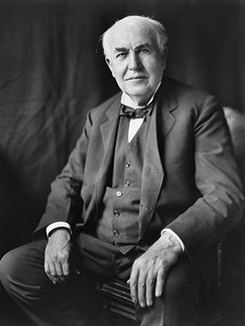
PHOTO CREDIT: WIKIPEDIA
We’ve all heard the name before. This famous American is attributed with failing over 10,000 times to invent a commercially viable electric lightbulb, but he didn’t give up. When asked by a newspaper reporter if he felt like a failure and if he should give up, after having gone through over 9,000 failed attempts, Edison simply stated “Why would I feel like a failure? And why would I ever give up? I now know definitely over 9,000 ways an electric lightbulb will not work. Success is almost in my grasp.”
This is also the same person whose teachers said he was “too stupid to learn anything,” and fired from his first two employment positions for not being productive enough. However, Edison, through his failures, is also the greatest innovator of all time with 1,093 US patents to his name, along with several others in the UK, and Canada. This is someone who refused to ever give up no matter what.
It’s said that in his early days, he attributed his success to his mother, who pulled him out of school and began to teach him herself. It’s because of his mother, and how wholeheartedly she believed in him, that he didn’t want to disappoint her. His early fascination for chemical experiments and mechanical engineering paved the way for a future that was incredible bright. His company, GE, is still one of the largest publicly-traded firms in the world, continually innovating across virtually every spectrum.

#11 – Walt Disney
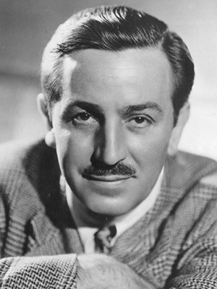
PHOTO CREDIT: WIKIPEDIA
The man who has affected generations to come with his cartoon creations, was once considered a failure. Disney was fired by the editor in 1919 from his job at the Kansas City Star paper because he “lacked imagination and had no good ideas.” However, the man who brought us Mickey Mouse and a slew of other characters didn’t stop failing there.
Disney’s first go at business landed in bankruptcy when he acquired an animation studio by the name of Laugh-O-Gram. The company was acquired because, at the time, Disney’s cartoon creations had gained popularity in the Kansas City area. But, when he hired on salaried employees, he was unable to manage money and the business wound up heavily in debt. Subsequently, he filed for bankruptcy and moved to Hollywood, California.
The early failures in Disney’s life didn’t dissuade him from moving forward. Of course, like anyone else, Disney’s failures were a blow to the ego. Anyone that has to suffer through the torment of failure and bankruptcy knows how this feels. However, it also laid the foundation for a successful career. When he formed the Walt Disney Company, all of his past failures helped to pave the way for a successful business.
Disney and the Walt Disney Company have touched the lives of millions across the globe. From cartoons, to theme parks, and animated movies, both children and adults now enjoy the fruits of Disney’s labor. Had he given up, things would have been far different. But he persevered, even through bankruptcy.

#12 – Sir James Dyson
PHOTO CREDIT: GOV.UK
The Dyson Vacuum Cleaner is known around the world as the vacuum that doesn’t lose suction. But the idea for it was born long ago. Dyson first had the idea in his early 30’s when he became frustrated with his Hoover vacuum and its loss of suction. At the time, the disposable bag replacement market for vacuums was valued somewhere around the £100 million per year.
His big idea was to use the concept of cyclonic separation to create the world’s first bagless vacuum cleaner. It took Dyson 5,126 failures to finally get it right. When he did, at the age of 36, he was faced with more resistance when no distributor in the UK would take on the revolutionary product. No one wanted to buck the trend.
So, Dyson hit the Japanese market in 1983, with a hot pink version of his vacuum cleaner. It won an industrial award in Japan, and in 1986, three years after its first introduction, he was awarded his first US Patent for it. However, manufacturers still didn’t want to take it on in other companies, so Dyson formed his own company, in 1993 at the age of 46, to market the product.
Today, Dyson is worth more than £3 billion all because of his refusal to give up. He struggled through times of failure, sorrow, and regret, but he persevered.

FAMOUS PEOPLE WHO FAILEDFROM FAILURE TO SUCCESSJ.K. ROWLING REJECTIONSJAY-ZLONGREADSOPRAH WINFREYSTEPHEN KINGSUCCESSFUL PEOPLE WHO FAILED AT FIRST

